PLC-Based Automation of the De Lorenzo DL 2314 Process Control Trainer Using Siemens PLC
Table of Contents
Abstract 1
1. Introduction 1
2. Literature Study 2
3. Methodology 3
3.1 Overall Approach 4
3.2 System Architecture 4
3.3 Tools, Technologies, and Materials 5
3.4 I/O Mapping and Signal Assignment 5
3.5 Control Logic and Design Process 6
3.6 Safety and Interlocking Strategy 7
3.7 Flowchart Representation 7
3.8 Experimental Validation Procedure 7
3.9. Implementation 8
3.9.1 Step-by-Step Development 8
3.9.2 Key System Features 9
3.9.3 PLC Programming Implementation 9
4. Results and Analysis 10
4.1 Motor Control Results 10
4.2 Control Valve Operation Results 11
4.3 Heater Control Results 11
4.4 Performance Evaluation 12
4.5 Comparison with Expected Results 12
4.6 Observations 12
5. Conclusion 13

Abstract
Many laboratory process control trainers remain manually operated, limiting accuracy, repeatability, safety, and their relevance to modern industrial automation. This project aimed to automate the De Lorenzo DL 2314 Process Control Trainer using a Siemens Programmable Logic Controller (PLC) interfaced through the DL 2110B modular PLC trainer. The approach involved identifying system components, performing safe hardware integration, assigning digital input/output channels, and developing ladder logic programs to control the pump motor, motorized control valve, and thermal heater with appropriate safety interlocks. Experimental testing demonstrated reliable actuator response, consistent system behaviour, and effective prevention of unsafe operating conditions. The results confirm that PLC-based automation significantly improves operational control, safety, and educational value, successfully transforming the manual trainer into an industrially relevant automated process control platform.

1. Introduction
Automation is essential in modern industries because it improves productivity, safety, reliability, and control accuracy. The shift from manual to automated process control is driven by increasing process complexity, where small disturbances in variables such as flow, level, pressure, and temperature can reduce efficiency, affect product quality, and create safety risks. Programmable Logic Controllers (PLCs) are widely adopted to address these challenges due to their ruggedness, deterministic performance, modularity, and compatibility with digital and analogue instrumentation [1]. PLCs are commonly used in pumping systems, industrial flow processes, and thermal control applications requiring fast and precise operation [2].
Process control systems maintain variables within desired limits using sensors, actuators, and control logic. Industrial actuators include motors, pumps, control valves, and heaters, while sensors provide feedback for monitoring and safe regulation. These components are integrated through digital and analogue input/output (I/O) modules [3], making PLCs fundamental in industrial automation and increasingly important in laboratory education [4]. Many institutions use process control trainers to connect control theory with industrial practice [5]. Upgrading these systems with PLC-based automation improves their industrial relevance and strengthens practical learning. Despite technological advancement, many laboratory trainers especially in developing environments remain manually operated. Manual control involves physical switching of actuators such as motors, valves, and heaters. While useful for basic demonstrations, it limits accuracy, repeatability, safety, and efficiency, and may create inconsistent experimental conditions that reduce research reliability [6].
The De Lorenzo DL 2314 Process Control Trainer is widely used to study flow, pressure, level, and thermal behaviour in a real process loop [7]. However, manual operation does not reflect modern industrial automation architecture and makes safety interlocks, automatic sequencing, systematic regulation, and real-time monitoring difficult to implement. This creates a gap between laboratory practice and the PLC-based skills required in industry [8]. Modernizing manual trainers presents technical challenges. Many systems lack standardized PLC wiring and clear I/O mapping, complicating hardware interfacing [9]. Successful automation requires correct identification of sensors and actuators, voltage compatibility, safe wiring, and accurate digital and analogue I/O assignment [10]. PLC implementation also relies on ladder logic programming, widely used because of its similarity to relay logic and ease of troubleshooting [11]. Safe control design is critical to prevent hazards such as unsafe motor operation, heater overheating, or pressure and flow shocks caused by improper valve actuation [12]. Although PLC automation is widely discussed in industrial and simulation-based studies, fewer works present practical hardware-based implementation on commercial educational trainers such as De Lorenzo systems with experimental validation [13]. Applied research is therefore needed to demonstrate systematic conversion methods.
This study addresses that need by automating the manual De Lorenzo DL 2314 trainer using a Siemens PLC interfaced through the De Lorenzo DL 2110B PLC modular trainer [14]. The DL 2110B provides digital and analogue I/O terminals that link the PLC with process components. The automation focuses on three key actuators:
- Motor control using Siemens PLC to achieve pump/motor start–stop switching.
- Motorized control valve control using Siemens PLC to enable automated valve actuation for process flow handling.
- Thermal heater control using Siemens PLC to automate heater operation for thermal experiments.
These represent fundamental industrial actuators, and prior work confirms the benefits of PLC-based pumping and thermal automation [2], [15]. Through proper wiring, I/O mapping, and ladder logic programming, the system is upgraded into a PLC-controlled platform that reflects real industrial automation practice. The study aims to design, implement, and experimentally validate this automation approach.
The remainder of the paper is organized as follows: Section 2 reviews related work, Section 3 describes the methodology, Section 4 presents results, and Section 5 concludes the paper.

2. Literature Study
Programmable Logic Controllers (PLCs) are widely recognized for their crucial role in industrial automation and engineering education. Multiple reviews highlight PLCs’ ruggedness, modular I/O, and suitability for teaching both discrete and continuous control systems, recommending their use in laboratory settings to connect theoretical concepts with hands-on skills [16]. The dominance of ladder logic in PLC instruction stems from its similarity to traditional relay logic, which aids students in debugging and understanding control processes [17]. Educational research shows that process control trainers equipped with PLC interfaces help students gain practical competencies in wiring, programming, and system troubleshooting, improving their readiness for industrial applications [18]. However, many studies focus on simulations or software training rather than detailed hardware integration on physical educational trainers. This creates a gap between theoretical simulation work and real-world PLC hardware implementation, especially in labs that still use manual control trainers. Commercial trainers such as the De Lorenzo DL-2314 provide a physical process loop for studying flow, level, pressure, and thermal dynamics, making them valuable platforms for introducing control system behaviour [19]. Standard DL-2314 documentation describes its use for basic ON–OFF and PID control experiments but does not fully address PLC retrofitting or automated control implementations. The De Lorenzo DL-2110 series serves as a modular PLC interface trainer, offering structured digital and analogue I/O terminals that simplify wiring between PLCs and process units [20]. When used together, the DL-2314 and DL-2110 trainers create an opportunity for educational automation exercises that better replicate industrial PLC environments. Despite hardware availability, few published works detail the step-by-step process of integrating PLCs with commercial process trainers, including sensor mapping, safe voltage interfacing, actuator wiring, and experimentally validated outcomes. Most literature in the broader automation field addresses industrial installations and theoretical methods rather than educational retrofits, underscoring a need for practical case studies in academic settings [21]. Actuator-specific automation has been explored in related domains: PLC-based motor and pump control systems improve repeatability and safety compared to manual operation, while PLC control of thermal systems demonstrates enhanced response and protection through logic-based interlocks [22][23]. Control valves, when integrated with PLCs, allow for finer flow regulation and sequencing, which contributes to improved overall process stability [24]. These applied studies support the selection of motors, valves, and heaters as key components to automate in educational trainers. Finally, pedagogical reviews recommend that successful modernization efforts should address four core areas, clear I/O mapping and standardized terminal use to reduce wiring errors; signal conditioning and voltage compatibility checks for safety and signal integrity; ladder logic programming that enforces safe sequencing and interlocks; and experimental validation to demonstrate improvements in accuracy, repeatability, and learning outcomes [25]. These principles inform the methodology of the present study, which focuses on PLC integration, ladder logic design, and validation experiments using a Siemens PLC interfaced via the DL-2110 trainer.

3. Methodology
This section describes the systematic approach used to convert the manual De Lorenzo DL 2314 Process Control Trainer into a PLC-based automated system using a Siemens PLC interfaced through the De Lorenzo DL 2110B modular PLC trainer.

3.1 Overall Approach
The project followed a hardware–software integration approach consisting of four main stages
System Study and Component Identification
All sensors, actuators, and signal types in the DL 2314 trainer were identified, including:
- Pump Motor
- Motorized control valve
- Thermal Heater
- Relevant switches and protection elements
PLC Interface Planning
The DL 2110B PLC modular trainer was used as an interface between the Siemens PLC and the process trainer. Input and output signals were analyzed to determine:
- Digital inputs (push buttons, limit/status signals)
- Digital outputs (motor starter, valve actuator control, heater relay)
Hardware Integration
Safe wiring was performed between the DL 2314 components and the PLC I/O terminals through the DL 2110B interface. Voltage compatibility and isolation were verified to protect both PLC and trainer hardware.
Control Logic Development and Testing
Ladder logic programs were developed to automate motor, valve, and heater operations with proper interlocks and safety conditions. The system was then tested experimentally.

3.2 System Architecture
The automated system follows a hierarchical control architecture consisting of sensing, control, and actuation layers as illustrating in Figure 1.
Main Components
- Process Plant: De Lorenzo DL 2314 trainer
- Controller: Siemens PLC
- Interface Module: DL 2110B PLC modular trainer
- Actuators: Motor (pump), motorized control valve, thermal heater
Signal Flow
Operator Commands / Status Signals
→ PLC Digital Inputs (via DL 2110B)
→ Ladder Logic Processing in Siemens PLC
→ PLC Digital Outputs
→ DL 2110B Interface Relays
→ Actuators on DL 2314 Trainer
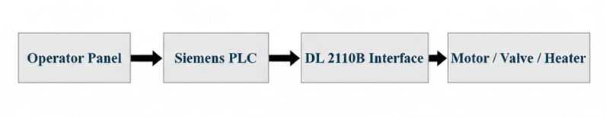
Figure 1. High-level block diagram depicting the hierarchical control architecture and signal flow from operator input to actuators.

3.3 Tools, Technologies, and Materials
The tools and technologies listed in Table 1 represent the essential hardware and software components required to implement the PLC-based automation system. The Siemens PLC serves as the main controller responsible for executing control logic and managing all input/output operations. The De Lorenzo DL 2314 Process Control Trainer provides the physical process environment, including the motor, control valve, and heater, while the DL 2110B modular PLC trainer functions as an interface platform that allows safe and structured wiring between the PLC and the process equipment. PLC programming was carried out using Siemens industrial software such as TIA Portal or STEP 7, with ladder logic (LAD) selected as the programming language due to its widespread industrial use and ease of troubleshooting. Additional electrical components, including interface relays, terminal wires, and connectors, were necessary to ensure proper signal transmission and electrical isolation between control and power circuits. Measurement tools such as a multimeter were used during installation and testing to verify voltage levels, continuity, and safe wiring connections. Together, these tools and materials enabled reliable hardware integration, accurate control implementation, and safe system operation.
Table 1. Hardware and Software Components of the Proposed Automation System
Category | Items Used
Controller | Siemens PLC (with digital I/O modules)
Training Systems | De Lorenzo DL 2314 Process Control Trainer, DL 2110B PLC Modular Trainer
Programming Software | Siemens PLC programming software (e.g., TIA Portal / STEP 7)
Programming Language | Ladder Logic Diagram (LAD)
Electrical Components | Interface relays, terminal wires, connectors
Measurement Tools | Multimeter for voltage and continuity testing

3.4 I/O Mapping and Signal Assignment
Table 2 summarizes the allocation of field devices to the PLC input and output channels, which is a critical step in designing an organized and reliable control system. Each actuator in the process trainer namely the motor, control valve, and heater—was assigned to a dedicated digital output channel of the PLC. These outputs send control signals to relays or contactors that drive the high-power devices safely. Operators push buttons and status signals were connected to digital input channels, allowing the PLC to receive commands and monitor system conditions. This structured I/O mapping simplifies wiring, reduces the risk of connection errors, and ensures that each device can be independently controlled and monitored through the ladder logic program. Proper signal assignment also improves troubleshooting and future system expansion, as every PLC address directly corresponds to a clearly defined physical component in the process setup.
Table 2. Input and Output Channel Allocation for Automated Process System
Device | Type | PLC I/O Type | Function
Motor Start/Stop | Actuator | Digital Output | Controls pump motor contactor
Control Valve Open/Close | Actuator | Digital Output | Drives motorized valve
Heater ON/OFF | Actuator | Digital Output | Controls heating element relay
Operator Push Buttons | Input Device | Digital Input | Manual command signals
This mapping ensured structured wiring and simplified ladder logic development.

3.5 Control Logic and Design Process
The control logic for the automated system was developed using ladder diagram programming in accordance with standard industrial safety practices. Ladder logic was selected because it is widely used in industrial PLC applications and provides a clear, relay-based representation of control operations, making troubleshooting and system verification more straightforward.
Motor Control Logic
The motor control logic was designed to manage the start and stop operations of the pump motor safely and reliably. When the start push button is pressed, the PLC energizes the motor output, activating the motor through an interfacing relay or contactor. Pressing the stop push button de-energizes the output, immediately stopping the motor. To enhance operational safety, an interlock condition was included to prevent automatic restarting of the motor after a power interruption. This ensures that the motor can only resume operation when a deliberate start command is issued by the operator.
Control Valve Logic
The control valve logic enables automated positioning of the motorized control valve used for regulating process flow. Separate commands were assigned for opening and closing the valve to allow directional control of the actuator motor. An electrical interlock was implemented in the ladder logic to prevent simultaneous activation of both open and close signals, which could otherwise damage the valve actuator. When either command is given, the PLC energizes the corresponding output, driving the valve in the selected direction while ensuring safe and controlled movement.
Heater Control Logic
The heater control logic was developed to automate the operation of the thermal heating element while maintaining safe working conditions. The heater is permitted to turn ON only when predefined safe operating conditions are satisfied within the control logic. A protection mechanism was incorporated to simulate overheating prevention by disabling the heater output if unsafe conditions are detected. Additionally, a manual OFF override function was included, allowing the operator to immediately shut down the heater regardless of the system state. This layered control strategy improves safety and reflects real industrial thermal control practices.

3.6 Safety and Interlocking Strategy
To ensure safe operation:
- Motor interlock prevents unintended start during faults
- Valve logic interlock avoids simultaneous bidirectional actuation
- Heater protection logic prevents operation without proper system state
- All high-power devices are driven through relays, not directly from PLC outputs

3.7 Flowchart Representation
The flowchart shown in Figure 2 represents the logical sequence of operations executed by the PLC during system operation. It illustrates how the control system continuously checks for safe operating conditions, reads input signals from operator commands and field devices, and processes the ladder logic program to determine the correct output actions. Based on this evaluation, the PLC updates the status of the motor, control valve, and heater outputs accordingly. This cycle repeats continuously, reflecting the PLC scan cycle used in industrial automation systems. The flowchart helps visualize the overall control strategy and clarifies how decision-making and safety checks are integrated into the automated process.
You can include a simple flowchart in the report like this:
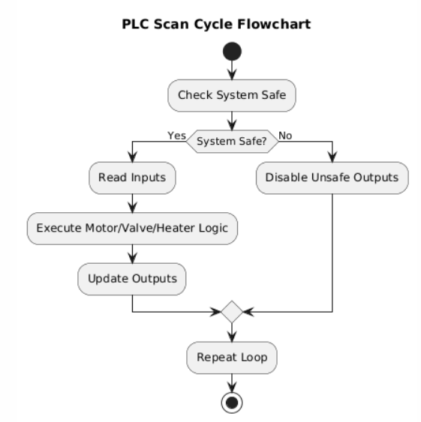
Figure 2. PLC Scan Cycle Flowchart for Motor, Valve, and Heater Control
This represents the PLC scan cycle used in automation.

3.8 Experimental Validation Procedure
After completing the hardware integration and ladder logic programming, a series of experimental tests were conducted to validate the performance of the automated system. Each actuator namely the motor, control valve, and heater was first tested individually to verify correct response to PLC commands and proper signal transmission through the interface module. The motor was checked for reliable start and stop operation, the control valve was tested for correct directional actuation, and the heater was verified for controlled switching behaviour. Following individual testing, combined operation tests were performed to observe system behaviour when multiple components operated simultaneously. These tests ensured that the control logic handled interactions between actuators correctly and that no unintended operations occurred. System response time, output consistency, and sequencing behaviour were observed to confirm that the PLC executed commands in the intended order. Safety interlocks and protection logic were also evaluated under simulated fault conditions. Scenarios such as unexpected stop commands, conflicting valve signals, and unsafe heater operation were introduced to ensure that the programmed interlocks prevented hazardous states. The system consistently responded by disabling unsafe outputs and maintaining stable operation. The successful completion of these validation tests confirmed that the automated PLC-based control system operated reliably and in accordance with the intended design.

3.9. Implementation
This section describes the practical implementation of the PLC-based automation system developed for the De Lorenzo DL 2314 Process Control Trainer. The implementation involved hardware integration, PLC programming, and system testing to transform the manual trainer into an automated control platform.

3.9.1 Step-by-Step Development
The implementation began with a detailed examination of the DL 2314 trainer to identify all actuators and control elements involved in the experiments. The motor (pump), motorized control valve, and thermal heater were selected as the primary devices to be automated. Their electrical characteristics, operating voltages, and control requirements were carefully studied before integration with the PLC. Next, the Siemens PLC was configured using the appropriate digital input and output modules. The DL 2110B PLC modular trainer was then prepared as an interface unit to provide safe and organized wiring between the PLC and the process trainer Figure 3. Each actuator was wired through interface relays to ensure electrical isolation and to prevent direct loading of PLC outputs. After completing the wiring, PLC programming was carried out using Siemens programming software. Ladder logic routines were written for motor control, valve actuation, and heater operation, incorporating safety interlocks and manual overrides. The program was downloaded to the PLC, and initial dry tests were performed without energizing the high-power devices to confirm correct logical operation. Finally, live system testing was conducted with the trainer powered under supervision. The behaviour of each device was observed, and adjustments were made to timing, interlocks, and output logic to ensure stable and safe operation.
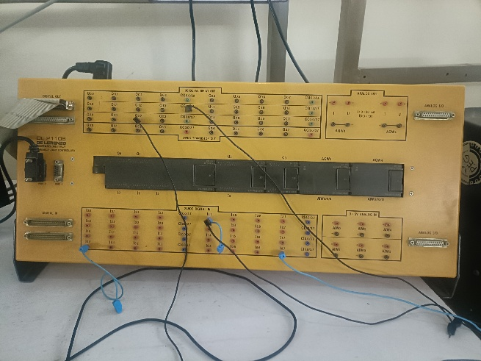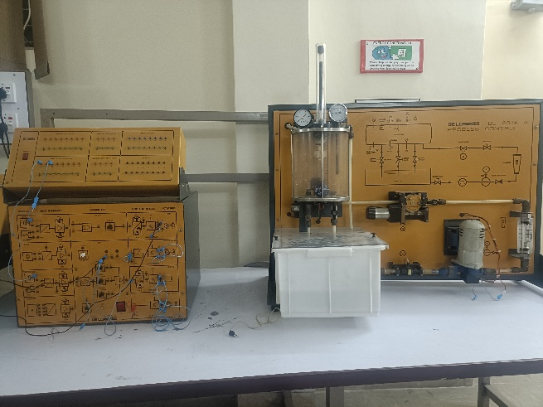
(a) (b)
Figure 3. Complete experimental setup showing DL 2314 process trainer interfaced with DL 2110B PLC modular trainer

3.9.2 Key System Features
The implemented automation system includes several important functional features. The motor control system allows safe start and stops operation through PLC logic with protection against unintended restart after power interruption. The control valve can be driven in both open and close directions using mutually exclusive commands, ensuring safe actuator operation. The heater is controlled through logic that allows operation only under safe conditions and includes a manual override for emergency shutdown. Additionally, interlocking logic prevents conflicting commands and ensures that all high-power devices operate through relay isolation for electrical safety.

3.9.3 PLC Programming Implementation
The ladder logic program in Figure 4 was structured into separate logical sections for motor control, valve control, and heater control. Each section includes input conditions, interlock rules, and output energizing coils. Timers and holding contacts were used where necessary to maintain stable states and avoid signal fluctuations. The modular programming structure simplifies troubleshooting and future expansion of the system.
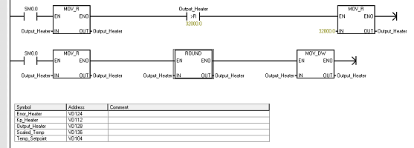
Figure 4. Ladder Logic Program Developed for PLC-Based Control of Motor, Valve, and Heater

4. Results and Analysis
This section presents the experimental results obtained after implementing the Siemens PLC-based automation system on the De Lorenzo DL 2314 Process Control Trainer. The performance of the motor control, control valve actuation, and heater control systems was evaluated to verify correct operation, safety, and system reliability.

4.1 Motor Control Results
The PLC-based motor control system was tested for start, stop, and restart behaviour as seen in Figure 5. When the start command was issued through the operator push button, the PLC successfully energized the motor output, and the pump motor started smoothly. Pressing the stop command immediately de-energized the output, and the motor stopped without delay. The interlock logic prevented automatic restarting of the motor after power interruption, requiring a new start command from the operator. These results confirm that the motor control logic operated as intended and provided improved safety compared to manual switching. The response was consistent across multiple trials, demonstrating reliable PLC control and proper interfacing through the DL 2110B module.
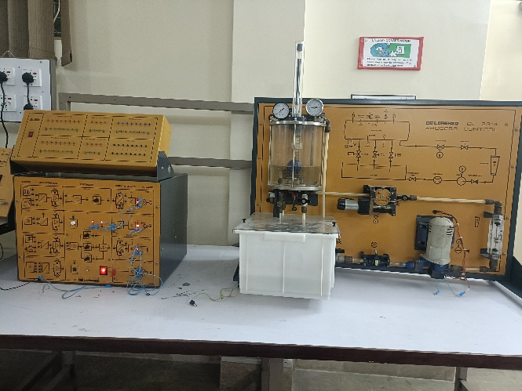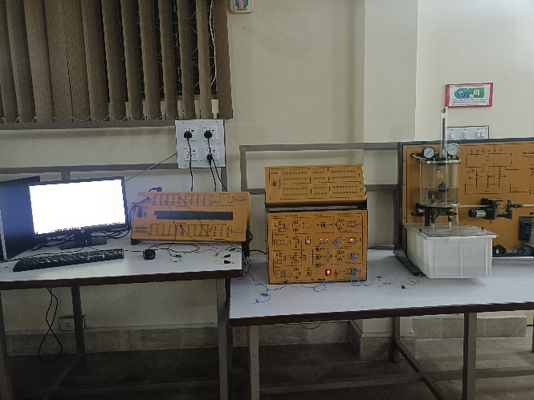
(a) (b)
Figure 5. Experimental Results of PLC-Based Motor Control (a) Pump motor operating after start command, (b) System setup during motor control testing

4.2 Control Valve Operation Results
The motorized control valve was tested using separate open and close commands from the PLC. The valve responded correctly to each command, moving in the intended direction without hesitation. The interlocking logic successfully prevented simultaneous activation of open and close outputs, ensuring safe actuator operation as illustrating in Figure 6. Repeated testing showed consistent valve movement and stable positioning behaviour. Compared to manual valve operation, the PLC-based control provided smoother and more controlled actuation, reducing the likelihood of sudden flow changes. This confirms that the automated valve system improved process handling and operational safety.
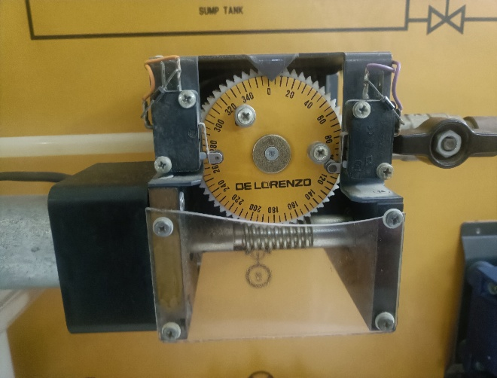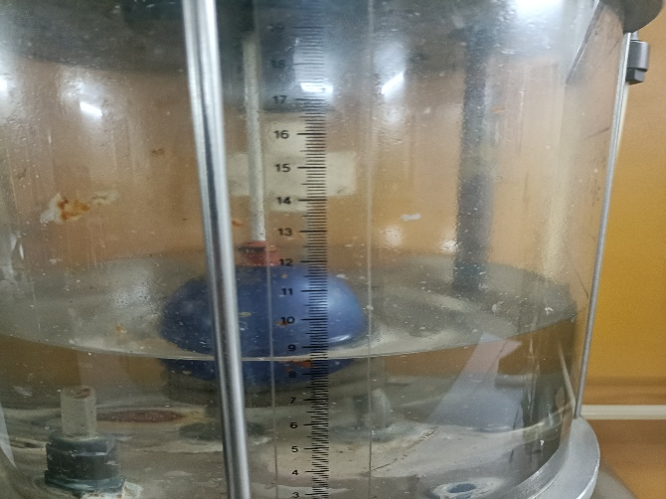
Figure 6. Experimental Results of Motorized Control Valve Operation Control valve position during actuation, Corresponding process tank level response

4.3 Heater Control Results
The heater control system was evaluated under normal and simulated unsafe conditions. When safe operating conditions were met, the PLC allowed the heater to turn ON as commanded. The heater switched OFF immediately when a stop or unsafe condition was introduced, demonstrating correct operation of the protection interlock logic as depicted in Figure 7. The manual override function also worked as expected, allowing the operator to disable the heater at any time. These results show that the PLC-based heater control enhanced operational safety and provided more reliable control than manual switching.
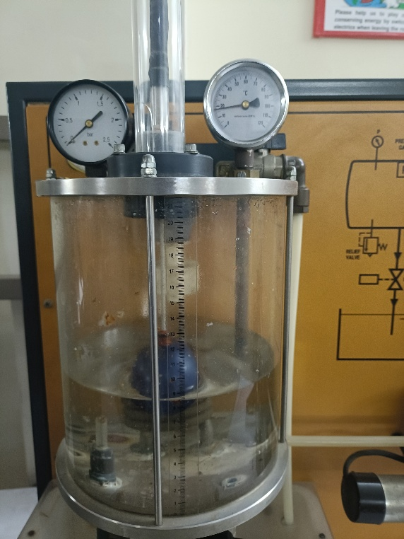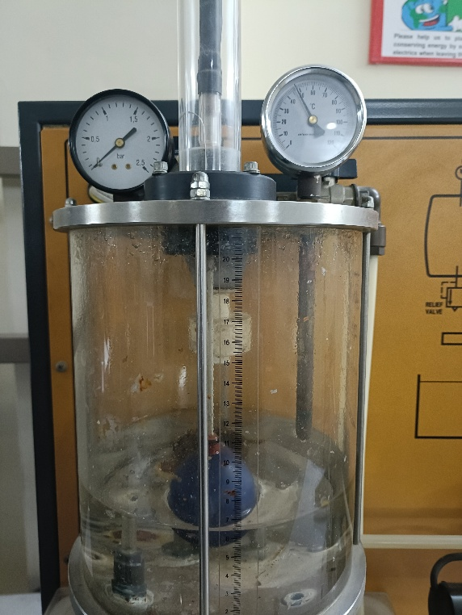
(a) (b)
Figure 7. Experimental Results of PLC-Based Heater Control (a) Tank condition during heater ON operation, (b) Tank condition after heater OFF due to safety interlock

4.4 Performance Evaluation
The automated system showed significant improvement in control accuracy, repeatability, and safety compared to the original manual operation. All three actuators responded consistently to PLC commands with minimal delay. The relay-isolated outputs ensured stable signal transmission without affecting PLC performance. No unintended operations were observed during combined system testing, indicating that the interlocking strategy was effective.

4.5 Comparison with Expected Results
The expected outcome of this project was to achieve reliable PLC control of the motor, valve, and heater while maintaining safe operation. The experimental results matched these expectations. Each actuator operated according to the programmed logic, and safety features functioned correctly under test conditions. The system behaved similarly to industrial PLC-controlled processes, confirming that the trainer was successfully upgraded from manual to automated operation.

4.6 Observations
During testing, it was observed that PLC control provided faster and more consistent response compared to manual switching. The use of structured I/O mapping simplified troubleshooting and system monitoring. The interlocks prevented hazardous or conflicting operations, demonstrating the importance of proper control logic design. Overall, the automated system improved operational efficiency, safety, and educational value of the trainer by closely resembling real industrial automation practice.

5. Conclusion
This project successfully automated the De Lorenzo DL 2314 Process Control Trainer using a Siemens PLC interfaced through the DL 2110B modular trainer, converting a manually operated system into a PLC-controlled platform that reflects modern industrial automation practice. The pump motor, motorized control valve, and thermal heater were effectively integrated through proper wiring, structured I/O mapping, and relay-based isolation, while ladder logic programs enabled reliable control and incorporated essential safety interlocks to prevent unsafe motor restart, conflicting valve commands, and hazardous heater operation. Experimental validation confirmed consistent and accurate actuator response, improved operational safety, and enhanced repeatability compared to manual control. The project objectives were fully achieved, demonstrating that systematic PLC integration can successfully modernize educational process trainers and significantly improve their technical capability and industrial relevance for practical learning.

References

16. E. R. Alphonsus, “A review on the applications of programmable logic controllers,” Renewable and Sustainable Energy Reviews. https://www.sciencedirect.com/science/article/abs/pii/S1364032116000551
17. M. Foster, “A review of programmable logic controllers in control systems education,” ASEE Digital Library. https://peer.asee.org/a-review-of-programmable-logic-controllers-in-control-systems-education.pdf
18. Educational PLC training studies (process control trainers with ladder logic). https://www.sciencedirect.com/science/article/abs/pii/S1877705816307820
19. De Lorenzo — DL-2314 Automatic Process Control Trainer manual. https://delorenzoglobal.com/wp-content/uploads/2024/04/DL-2314PLC-AUTOMATIC-PROCESS-CONTROL-TRAINER-1.pdf
20. De Lorenzo — Programmable Logic Controllers Modular Trainer (DL-2110). https://delorenzoglobal.com/en/product/programmable-logic-controllers-modular-trainer-3/
21. PLC implementation challenges and practical case studies scarcity in educational labs. https://www.sciencedirect.com/science/article/pii/S187770581735236X
22. PLC motor and pump automation studies showing improved repeatability and control. https://www.sciencedirect.com/science/article/pii/S0360835218300273
23. PLC-controlled thermal systems research demonstrating enhanced safety and regulation. https://www.sciencedirect.com/science/article/pii/S0360544218310418
24. Control valve automation and PLC integration benefits. https://www.sciencedirect.com/science/article/pii/S0957417419305117
25. Pedagogical recommendations for PLC education and training systems. https://www.sciencedirect.com/science/article/pii/S1877705818304958

